Project Report

Title - *High On Flight*

Submitted by,

Kavin Sagar S

Harikrishnan C L

Shivani Prabhakar

Madhavaraj T S

Kabilesh P

Department of Information Technology,

Sona College of Technology,

Salem.

Project Description:

Client Statement - Create a website for the airlines, from which user can see the details of the airlines, such as about the airlines, airlines schedule, airlines booking, contact details, address, images etc. .

Add Location information of Airlines office using google maps api or other apis in the contact page

The purpose of this project is to help the people looking for airline services. The world grows faster and we move along with it. In the move, airline network grows bigger and bigger each day. So that the users gets confused by many different untrusted networks. Our product will help the airlines customers around the world to know the details they are looking for. This product conveys proper information about the travel, availability of the tickets, fare for the tickets etc. We have created an enlarged home for our airlines, where the customers can know about our airlines in detail. This product has options to check availability of the flight. This product has options to choose the flight that the user wishes to travel. They can decide their requirements in travel. They are given with many different payment options to pay the fare in an easier and secured way. We have also given the contact information of the airlines. So that customers can stay connected with us through their words.

Vision of High on Flight airlines is to excite the passengers with our enormous love and ease.

Mission of High on Flight airlines is to build a big family.

Features / Functionality:

Our product has many features that help the customers to get a clear view about their travel. We have features like scheduling the flights for users, booking the flights for customers and contact section to stay in touch with us. In the scheduling section, the user can look for the list of flights available for their search.

Scheduling the Flights:

The ride becomes happier when it has a good plan. In the

Scheduling section, the user can look for the list of flights available for their search. They can use it to plan their travel time for their wish. The departure time, arrival time, total hours of travel, different classes that are available, fare for each class are all displayed to the user to plan accordingly.

Booking the Flights:

We always try to build a trusted relationship with the customers. The users can book tickets for their scheduled flights in this section. We have designed the booking interface in such a way that the user feels easy and safe to book their birds. The payments are made in most secured way that. So that user can pay the fare in a protected platform.

Contact Details:

The bond between the customer and the administration helps the organization grow bigger. We have designed a contact page where the customers and users can stay connected with us all the time.

About High on Flight:

The history speaks the future. In such a way the about section describes the history and evolution of High on flight airlines.

User Stories:

|  |  |  |  |  |
| --- | --- | --- | --- | --- |
| **Rank** | **As a (n)..** | **I want (to)..** | **So that** | **Acceptance criteria** |
| 1 | Admin | establish a platform for the Airlines | the platform bridges the users and the admins | Establishment |
| 1 | Product owner | Launch a website | the website accepts the user input and progresses it | Website functioning |
| 1 | Developer | create a website in the development environment | starts using and accessing the website | >new project created, added to source control, demo environment ready if needed  >apply the theme chosen by product owner to master cycle |
| 2 | Admin | assigns attendants | the user requirements are fulfilled | the users are shown the availabilities |
| 3 | Admin | assigns parameters | the user can seek for the events respective to their requirements | parameters are associated with the process and the users |
| 4 | User | feed in the requirements | the user can get the result and benefit from it | >create a profile which includes the contact information, payment information  > receive viewable/printable confirmation of event reservation |

Tools and Technologies:

Tools – Visual Studio Code, Notepad++.

Technology – Github, Jira, Slack.

We used Visual Studio Code, Notepad ++ for designing this website. Html and CSS played a major role in this project. Also we used jira and github to upload and deploy our project. We also used Slack platform to have communication with the guides.

URL :

<https://kavinsagar.github.io/teamseven/home.html>

ScreenShots :

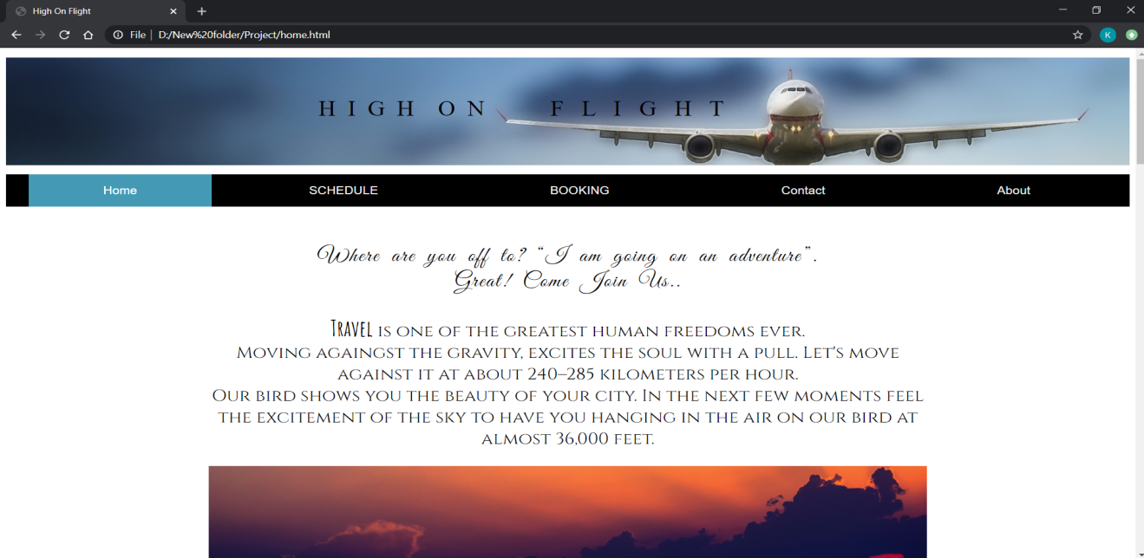

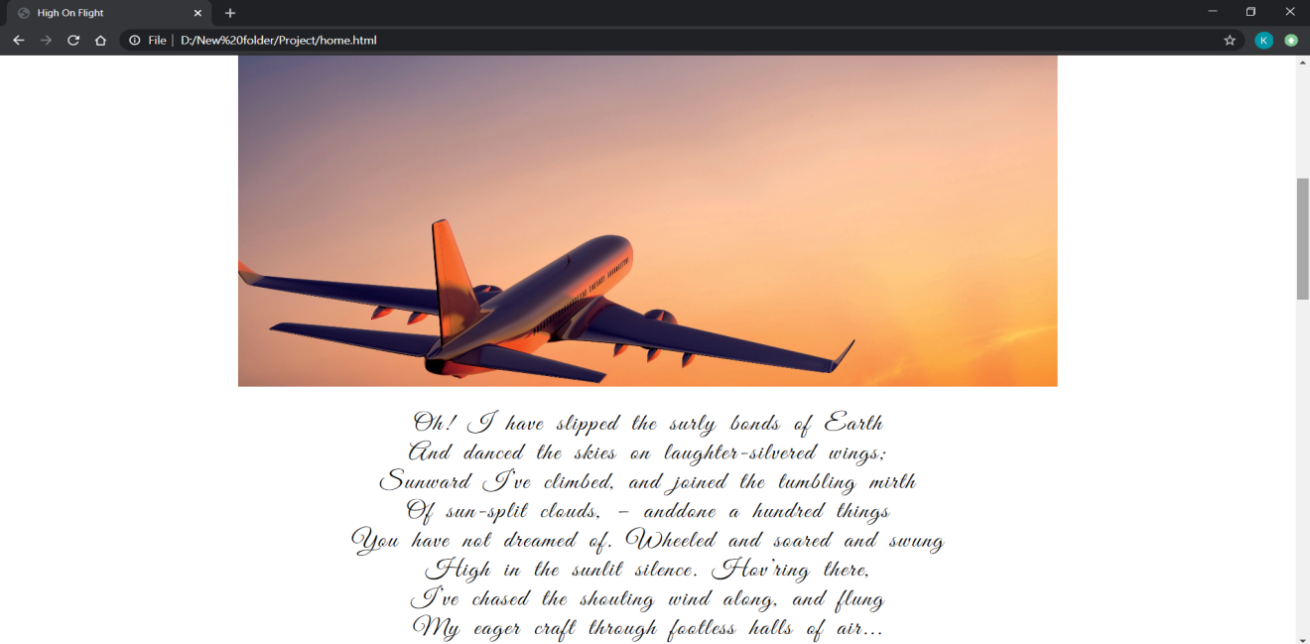

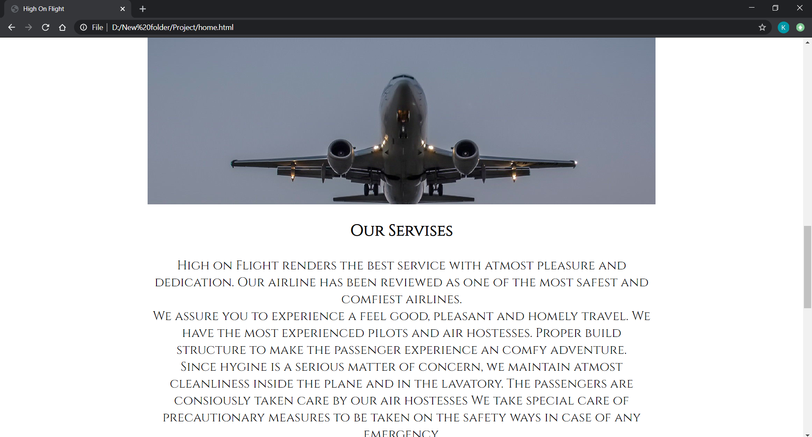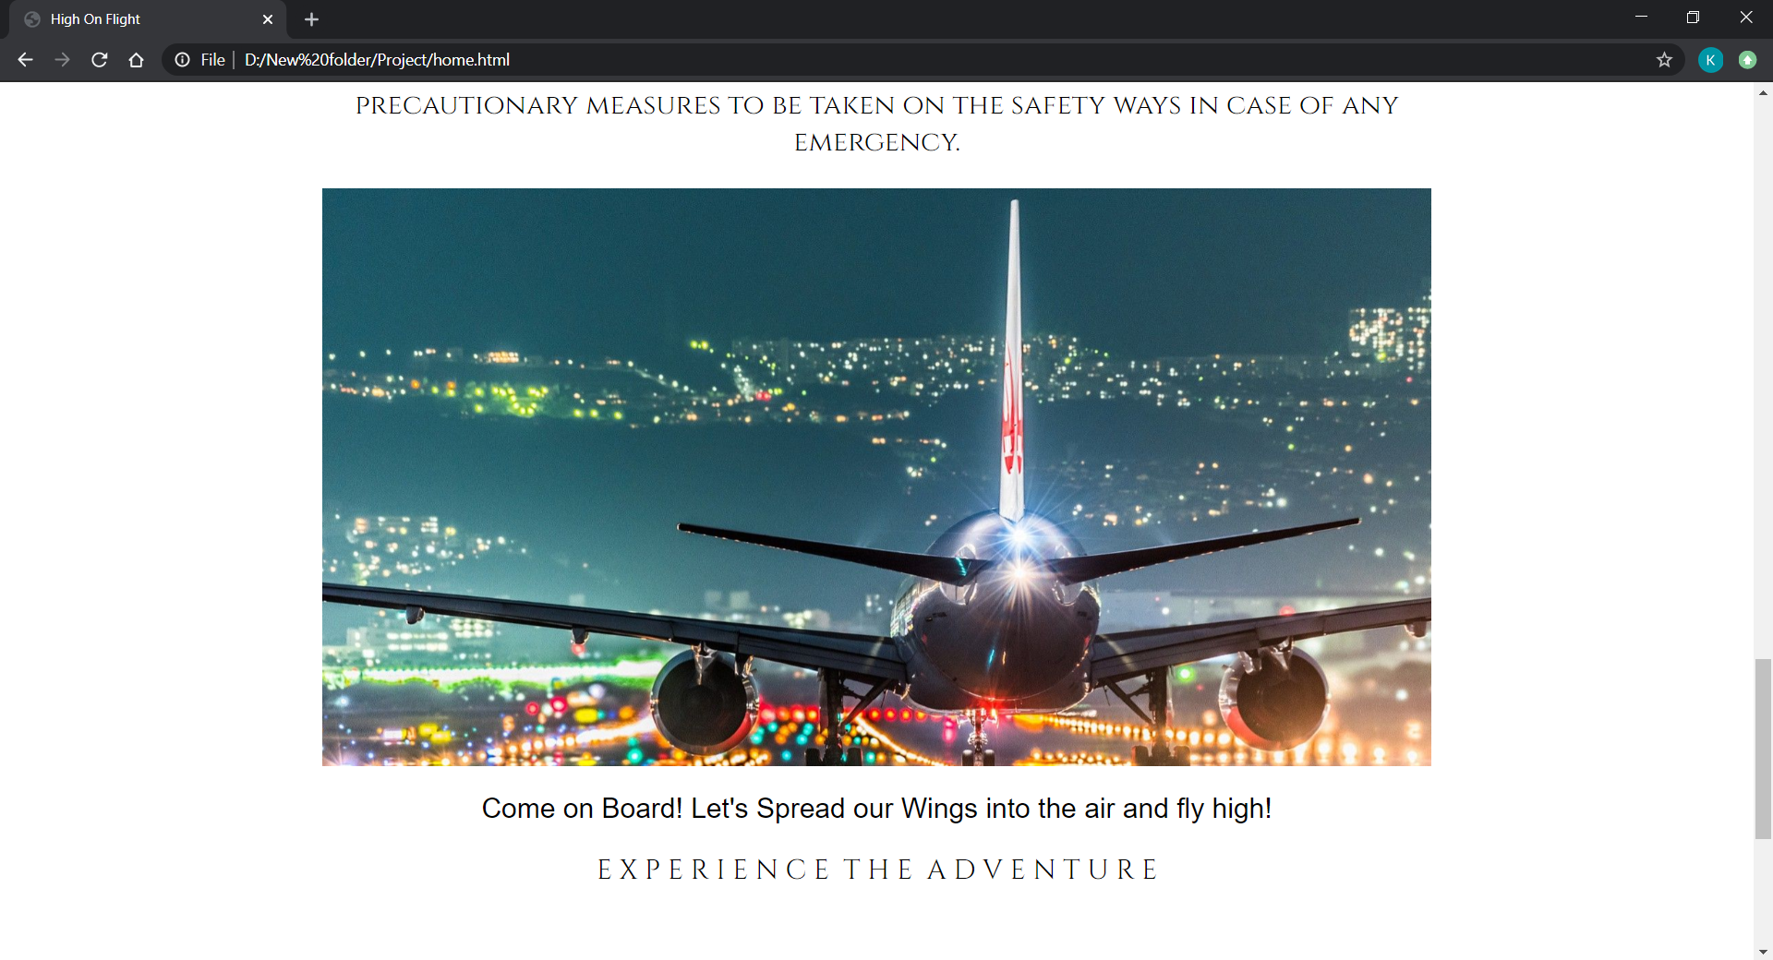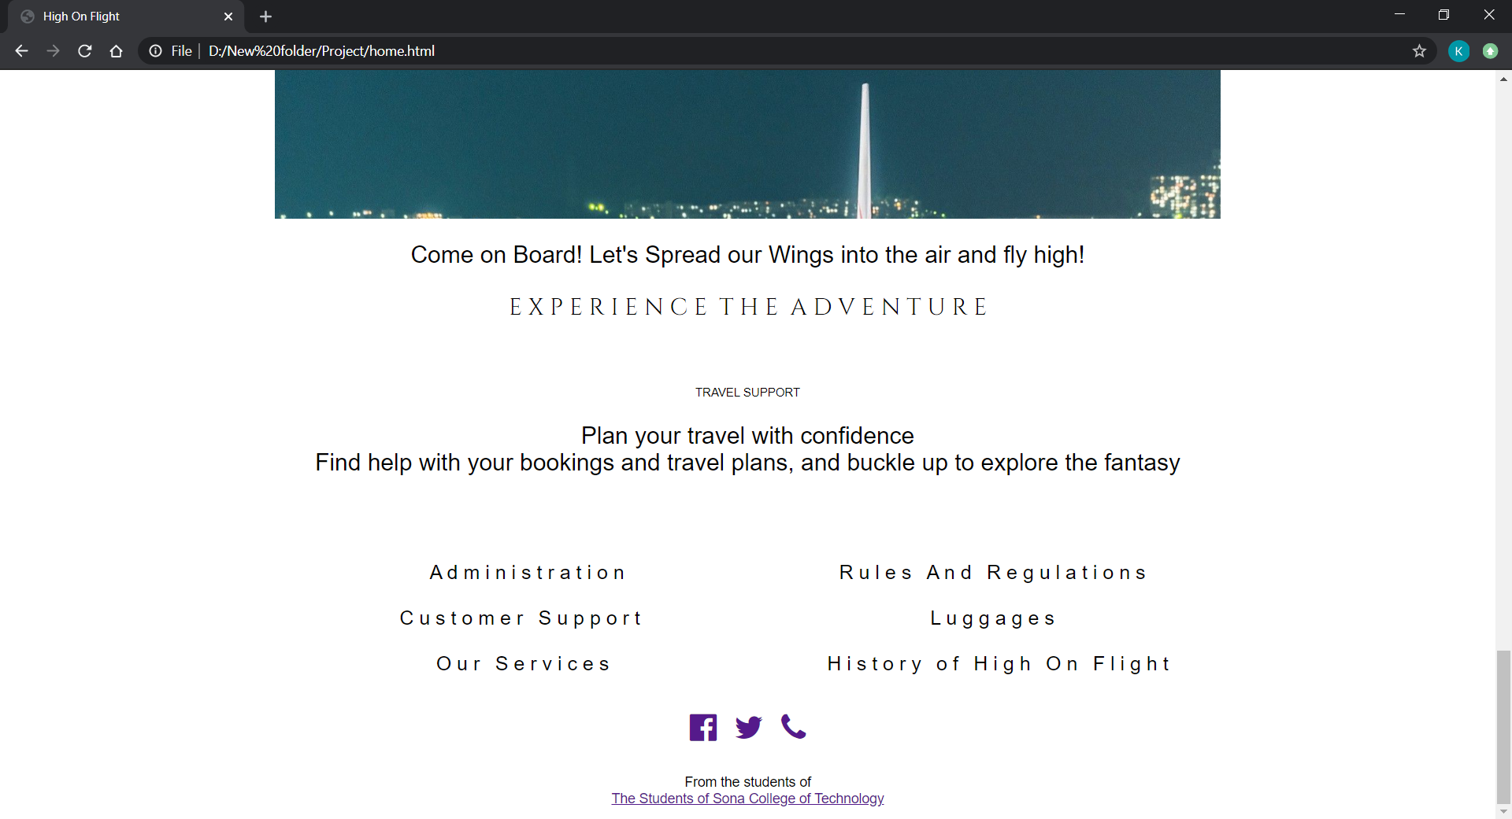

Schedule Page:

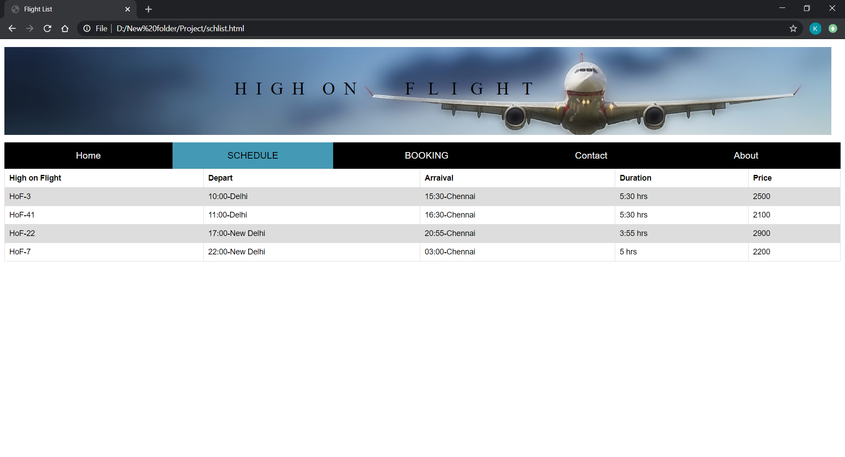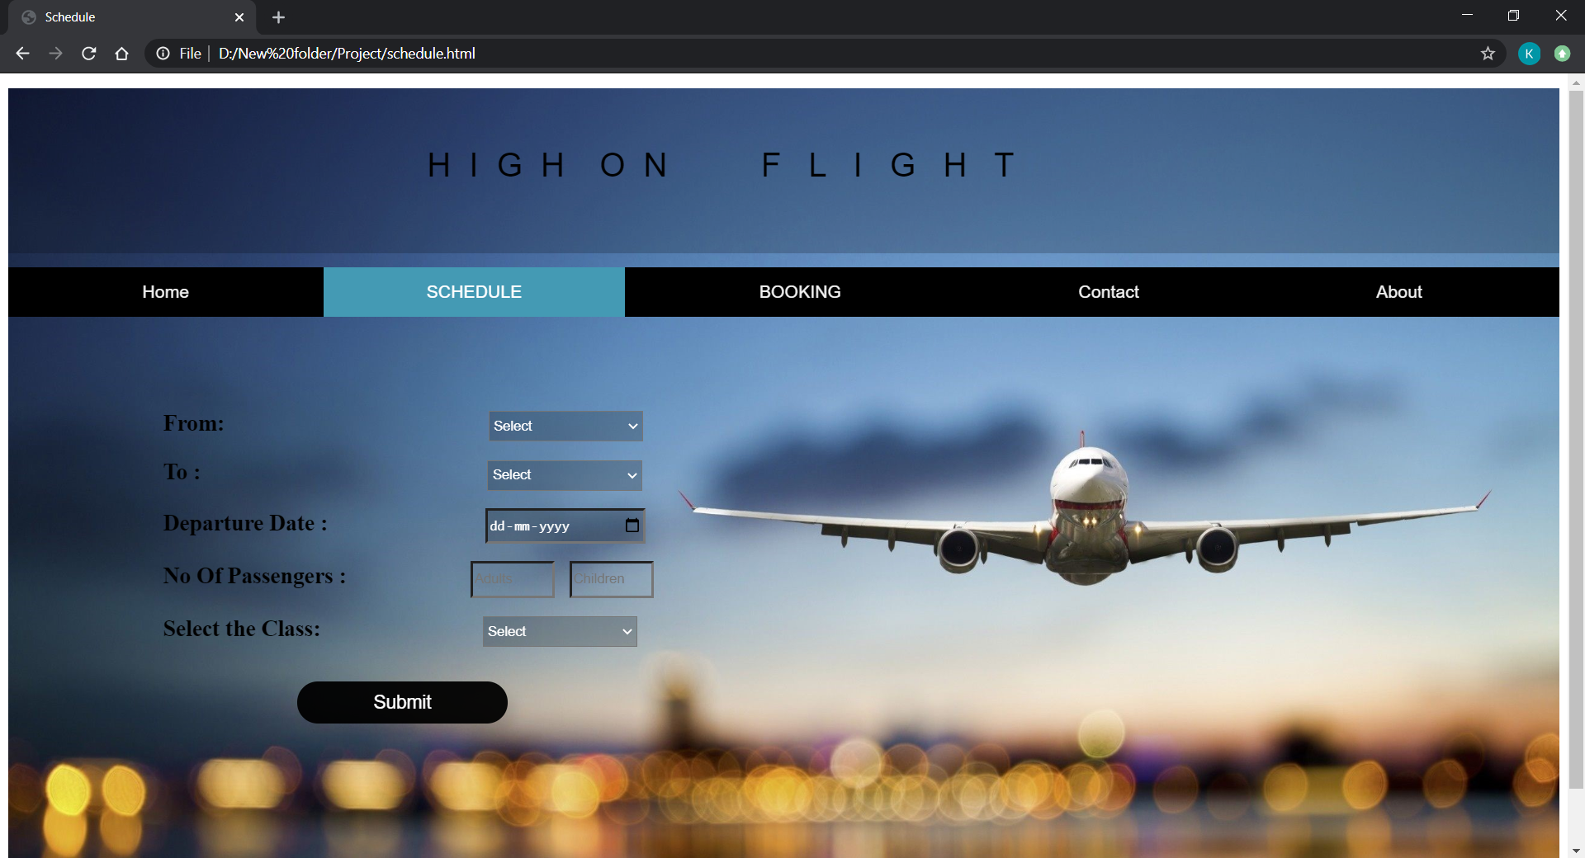

Booking Page :

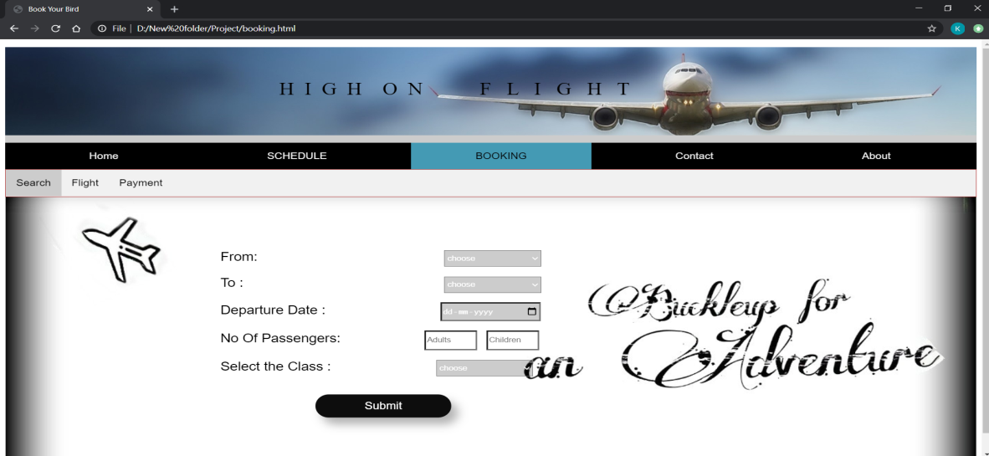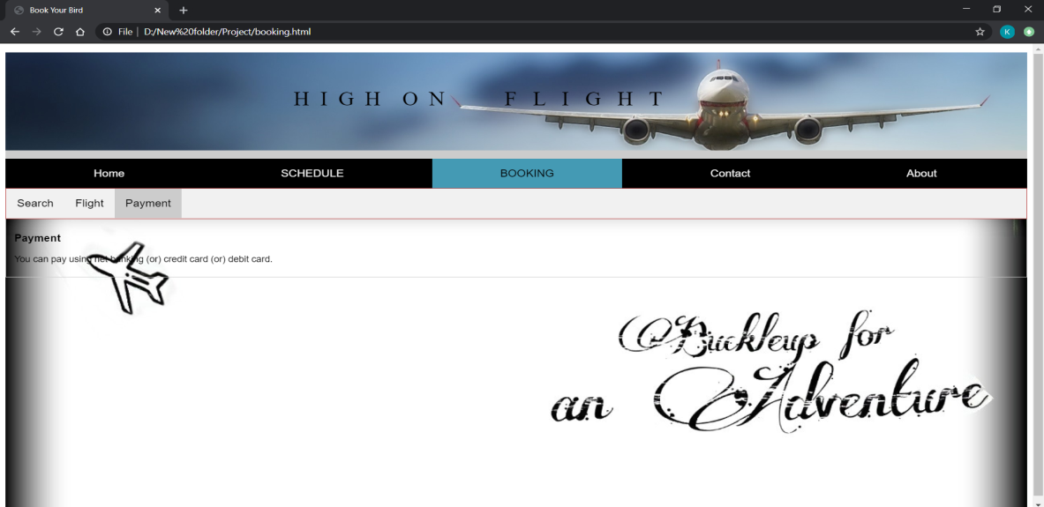

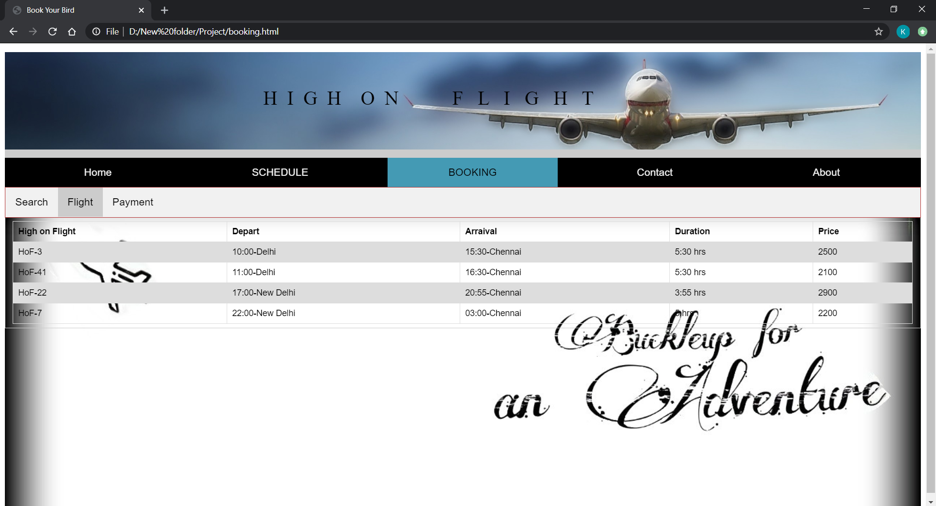

Contact Page :

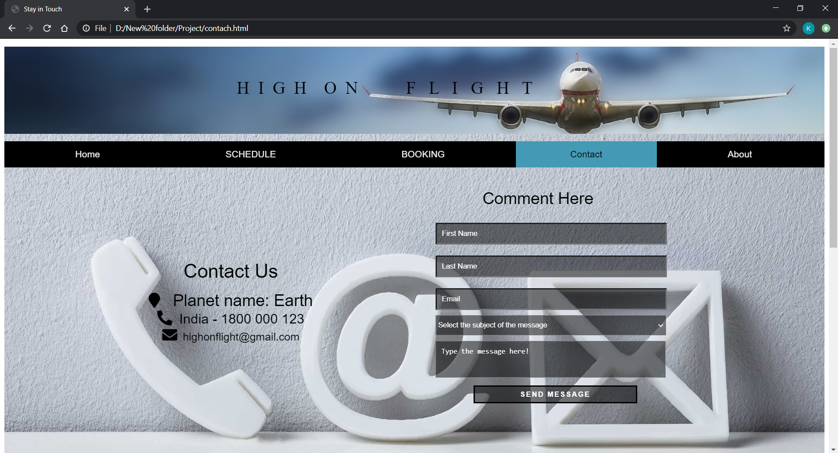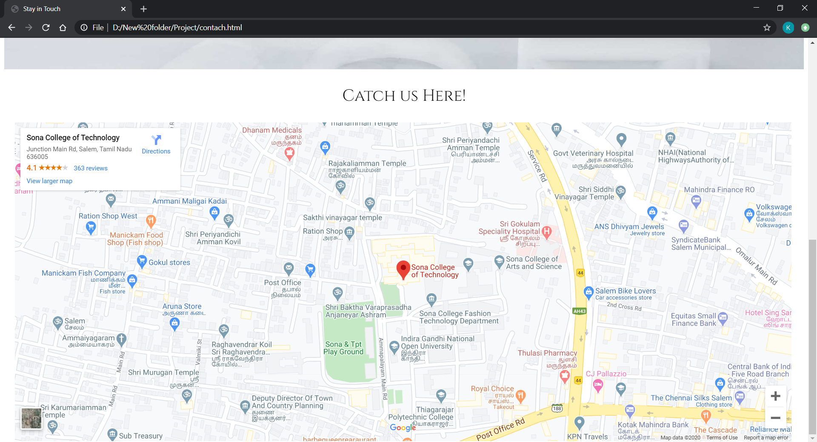

About Page :

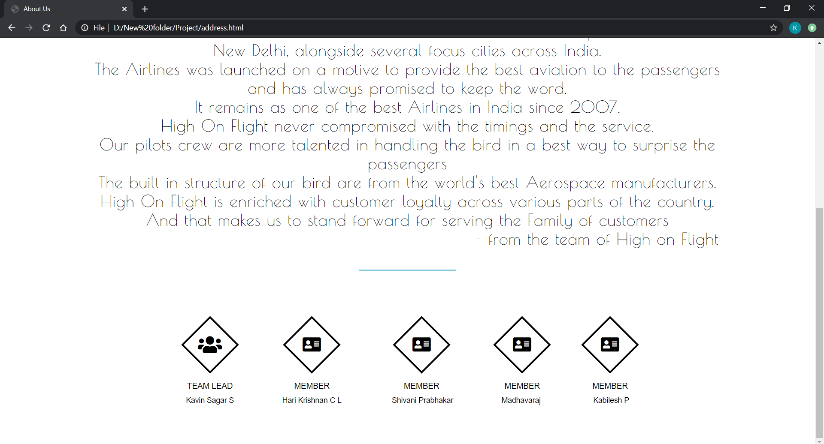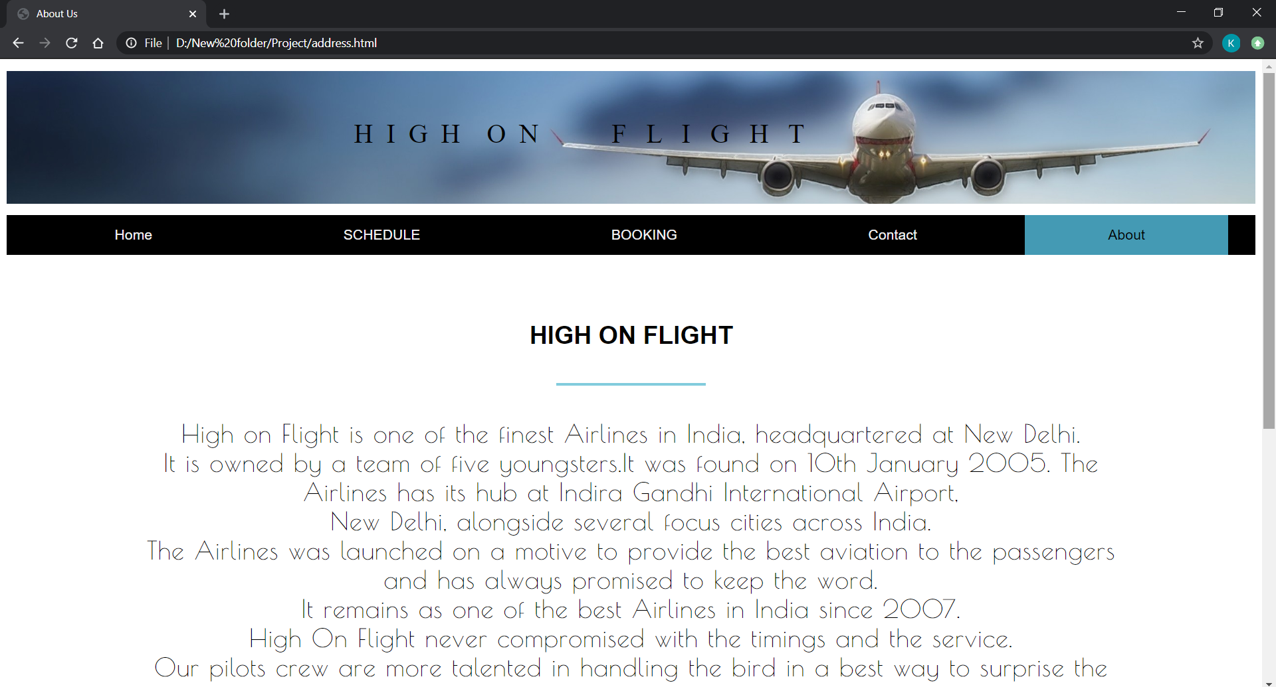

Our PPT demo is attached below.

https://drive.google.com/file/d/1e6cgVHEvb0c_bz2zrV3amRZTIxpF51mw/view?usp=sharing